Inclusion Policy

Ralph J. Bunche Middle School

Atlanta, Georgia

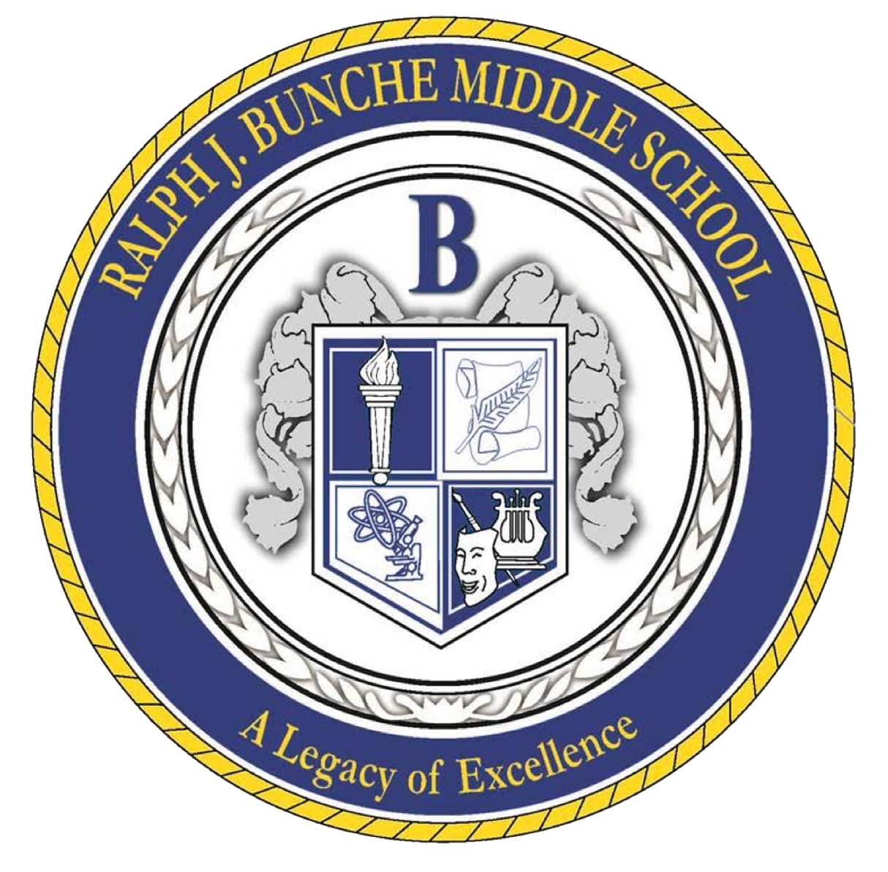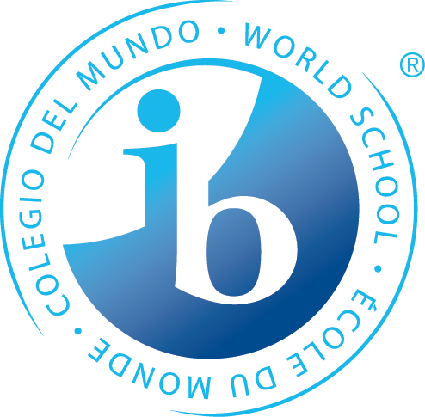

**The Bunche Mission Statement**

Through rigorous learning experiences and a challenging international education program, Ralph J Bunche will develop 21st-century lifelong learners who are competent, caring, and contributing members of a global society prepared for high school and beyond.

**Introduction**

According to the IB publication *Special Educational Needs within the IB Programmes* (2010), “Inclusion is an ongoing process that aims to increase access and engagement in learning for all students by identifying and removing barriers.” Utilizing the IB MYP *Programme Standards* *and Practices* (2014), *APS Special Services and Programs Policy*, Federal policies and guidelines, and the beliefs outlined in our mission statements, Ralph J. Bunche Middle School (BMS) strives to support a diverse student body of learners. Whether through teaching and learning strategies, resources, or collaboration with experts and parents, our students are supported throughout the IB Middle Years Programme.

**Philosophy**

Ralph J. Bunche Middle School acknowledges and appreciates the individuality of our diverse population. We recognize students with obstacles affecting their educational experience and implement strategies and support to help them persevere. We agree that inclusion is a priority to facilitate each student's academic success. We also accept the responsibility to provide equal access to the curriculum and academic rigor, regardless of individual abilities and needs.

**Definition of Inclusion**

In the IB document *Special Educational Needs within the IB Programmes* (2010), “inclusion is more about responding positively to each individual’s unique needs … (and) less about marginalizing students because of their differences.” The Individuals with Disabilities Education Improvement Act (IDEA) and Georgia Administrative Code mandate that districts provide services to students with disabilities in the least restrictive environment possible; they educate students without disabilities to the greatest extent feasible. To this end, Atlanta Public School District provides special education and related services at each school site. This model increases the possibility of providing an appropriate education to students with disabilities at their neighborhood school. Each school is staffed with special education teachers. In addition, itinerant staff persons (school social worker, school psychologist, school nurse, occupational and physical therapist, speech/language pathologist, and others) are available to complete assessments, participate in the IEP process, and provide services as necessary. All special education professional staff is appropriately licensed through the Georgia Department of Education. Paraprofessionals are often available to assist in the implementation of students' IEPs.

Ralph J. Bunche Middle School utilizes the inclusion model. The Special Education Resource Teacher collaborates with general education classroom teachers to provide support and specifically designed instruction to meet the unique needs of all students. Responsibilities of Resource Teachers include working in the classroom setting, working with individual or small groups of students to reteach/reinforce concepts taught, and modifying curriculum and assessments based on student needs. The Resource Teacher must be an experienced and knowledgeable teacher who can provide leadership to help build teacher capacity for utilizing differentiated pedagogical strategies in the classroom. The resource teachers also teach supplemental classes that focus on academic gaps and are tailored to specific goals and student needs. This class is a time where students track and reflect on data relevant to their individual goals, learn techniques for advocacy, and focus on organizational strategies and other approaches to learning strategies.

**Definition of Differentiation**

In the past, differentiation was either for the talented and gifted student or the struggling learner. Currently, it is an accepted practice for all students. The document *Special Educational* *Needs within the IB Programme* (2010) identifies differentiation as “a teacher’s response to the diverse learning needs of a student” and “sound practice and principles for all students.” Additionally, the document states, “Differentiation is seen as the process of identifying, with each learner, the most effective strategies for achieving agreed goals.” Students must be involved in developing learning goals that meet their individual needs.

**Four Principles of Good Practice**

According to the document, *Special Educational Needs (SEN) within the IB Programmes* (2010), “Teachers new to IB programmes may require factual and procedural knowledge when teaching SEN students, such as:

* Information about factors that affect a student’s learning, particularly about inquiry-based learning
* How best to respond to the student’s needs
* How to differentiate and match teaching approaches to the student’s needs, as indicated in the school’s SEN policy
* Knowledge of technology that has assisted in alleviating and removing barriers to learning.”

Keeping this information at the forefront, we have identified our principles of good practice, aligned with the four principles of good practice that the IB has determined to promote equal access to the curriculum for all learners.

**1. Affirming identity and building self-esteem**

Valuing the diverse needs of all learning community members supports identity and encourages self-esteem. Creating an environment where all students feel accepted makes them more receptive to developing the Learner Profile traits. Students who think confidently supported in their academic endeavors are more likely to be risk-takers who participate actively in class and inquirers who pursue further learning opportunities. When we positively acknowledge students' differences, they are more apt to be open-minded.

• We promote an environment that welcomes and embraces the diversity of all

learners. For example:

* Utilizing an inclusion model with academic and social skills support
* Implementing cooperative learning groups
* Supporting opportunities to engage in all extra-curricular activities and intramural sports

• We value and use the diversity of cultural perspectives to enhance learning. For example:

* Encouraging student sharing of backgrounds and cultures
* Celebrating critical historical events from other countries that are modified to student ability levels
* Utilizing multi-media to expose students to various cultures and perspectives

• We communicate with parents to establish an understanding of how best to

collaborate to achieve shared goals.

For example:

* Quarterly reports to parents regarding progress toward individual student goals
* Weekly special education department meetings with itinerants
* Weekly grade-level and department meetings with general education teachers and Administrators

**2. Valuing prior knowledge**

Students must learn and retain new knowledge tied to their existing knowledge, distinct to each student. The IB document, *Special Educational Needs* *within the IB Programmes* (2010), states that “when planning the range of new learning that can take place in any individual, teachers must take into consideration previous learning experiences or prior knowledge.” Activating and building background knowledge prepares students for further learning.

To accomplish this goal:

* We activate the learner’s prior understanding.
* We use students’ prior understanding to differentiate tasks and activities to build up further background knowledge necessary for new learning.
* We record information in learning profiles that support planning for future

differentiation and inform teacher practice.

* We consider the time and strategies necessary for activation and building up background knowledge when planning a unit of work or lesson.

**3. Scaffolding**

Through scaffolding (instructional techniques used to move students progressively towards more robust understanding and, ultimately, greater independence in the learning process), we can increase students’ level of independent learning. According to the IB document, *Special Educational Needs within the IB Programmes* (2010), “scaffolding should foster learners’ increasing independence in taking responsibility for developing strategies for their learning.” We work with all individuals and small groups of students to reteach/reinforce concepts taught and accommodate curriculum and assessments based on student needs. We utilize a variety of techniques and strategies in the classroom, including:

* Visual aids, demonstrations, dramatizations
* Differentiated graphic organizers, small, structured collaborative group instruction
* Language suited to learner-specific ability/understanding
* Native language or best language to develop ideas
* Assistive technology enables learners with language needs to access material for metacognitive engagement.
* I leveled reading materials: non-fiction, novels, short stories, poetry, etc.

**4. Extended learning**

We provide students with learning experiences that extend their thinking and take learning to the next level. The IB document, *Special Educational Needs within the IB* *Programmes* (2010), states that “teachers can help learners extend their learning by combining high expectations with numerous opportunities for learner-centered practice and interaction with cognitively rich materials and experiences.” We strive to provide student-centered classrooms driven by inquiry. Students can work collaboratively with their peers while interacting with various contexts and concepts. Students learn to communicate more effectively, think deeply, and cultivate intercultural understanding.

**Interventions for Suspected Learning Disabilities**

Ralph J. Bunche Middle School follows the Atlanta Public School District policies and procedures to determine eligibility for special educational needs. If a classroom teacher is concerned about a student’s progress in a particular area, they will employ interventions to improve their performance. There are a variety of methods a teacher may choose to accomplish this result. If the student continues to have difficulty, the teacher will meet with other school staff and parents to discuss the child’s needs, consider other interventions, and outline a method to monitor the student’s progress carefully. The insight and expertise of the various school staff members and parents come together to make a final determination regarding student progress. The school implements the Response to Intervention (RTI).

RTI is a process that provides interventions and educational support to all students at increasing levels of intensity based on their individual needs. The goal is to prevent problems and intervene early for students to be successful. RTI is designed to help schools focus on interventions that match student needs and are monitored regularly. School personnel and parents use the information gained from the RTI process to adapt instruction and make decisions regarding the student’s educational program.

Suppose the three-tiered RTI interventions produce inconsistent or unsuccessful results. In that case, the Special Education Lead teacher and other personnel complete a referral to psychological services to request a full comprehensive psychological exam by an Atlanta Public Schools psychologist. Along with the data collected during the RTI process, a variety of other information is presented with the referral to rationalize the need for the evaluation. The child's family or teacher can also request a comprehensive psychological evaluation. Additionally, RTI must run concurrently to adhere to the compliance timeline set by the district.

After the psychological evaluation, we utilize several components to determine if a student qualifies for specially designed instruction through special education. The RTI data, the review results, and the Special Policies and Procedures Manual outline the requirements for eligibility and are all used to conclude eligibility for special education. An Individual Education Plan (IEP)is developed based on the findings and input of the teachers and family.

Suppose the eligibility team, consisting of the parent, teachers, special education teacher, and psychologist, determines that students are ineligible. In that case, the team refers the student to the Student Support Team (SST) for 504 consideration.

**Supports**

Support for students with special educational needs and abilities includes pull-out assistance, collaboration, and consultation. A certified special education teacher provides pull-out services in reading, English language arts, and math to students who require this service. These students are removed from their general education classroom and placed in a small group setting to work on their individualized goals. They are also provided with strategies to help promote mastery of grade-level standards. A certified special education teacher also offers collaboration and consultation services. These services include observations, support facilitation, consultation, and collaboration with students, teachers, staff, and parents to help support struggling learners. General education teachers provide differentiated approaches to learning to help reach students of all learning styles. Special education teachers and the lead special education teacher support general education teachers in implementing effective strategies for students with IEPs.

**Assessments**

In addition to the district and state-required standardized assessments, special education students are given additional assessments to identify their current instructional levels and enable teachers to provide the most effective support.

**Documentation**

The Special Education teachers organize data relating to the academic achievement of all special education students to continually assess if a student’s needs are being adequately met. Precise data and logs are collected on students who receive all types of support (pull-out, collaboration, and consultations.) Documentation of services received is also provided through the district’s web-based platform. All kinds of documentation are used to generate a student’s IEP and identify the best support they will benefit from.

**Special Needs Under Section 504**

To be protected under Section 504, a student must be determined to have a physical or mental impairment that substantially limits one or more major life activities (walking, seeing, hearing, speaking, breathing, learning, working, caring for one’s self and performing manual tasks, have a record of such an impairment, or be regarded as having such an impairment). Determining whether a student has a physical or mental impairment substantially limiting a significant life activity must be made individually. The Lead Special Education teacher and the appropriate team members generate a 504 plan. This plan includes accommodations to offer equal access to the curriculum on an individualized basis. Funding is not attached to 504 plans.

**Gifted and Talented Learners**

Students identified as gifted and possessing a current Education Plan (EP) receive grade-level enrichment services through a pull-out model. Each gifted-endorsed student enjoys 150 minutes of specialized instruction per week, conducted over three sessions, with a certified gifted-endorsed teacher in a small group setting. This approach allows our gifted population to receive tailored enrichment in their areas of strength, whether math, reading, writing, or research.

Moreover, our pull-out model enables us to group gifted students by age, gender, and area of giftedness, facilitating the implementation of tasks designed to help them reach their highest potential. The gifted-endorsed teacher also collaborates with general education teachers to enhance the learning experience for gifted students within their regular classrooms. Additionally, each student receives a gifted folder containing the tasks they are working on during their pull-out sessions. After completing their required assignments, they can further engage with these tasks in their general education classes.

**Accommodations**

Based on a student’s Individualized Education Program (IEP), accommodations may be applied to all tasks, including assessments. These accommodations include but are not limited to extended time for oral and written responses, reduced item counts on tests or answer choices, oral reading of test questions, small group testing, the use of calculators or formula charts, assistive technology, and paper-based materials. Staff members undergo professional development sessions to ensure they can implement these accommodations effectively within the general education classroom. Support is provided as needed to address specific accommodation requirements. A comprehensive testing database for all grade levels is maintained to ensure the testing coordinator knows all necessary accommodations for each student during district and state standardized assessments.

**Communication**

Teachers and families meet throughout the school year to address the student’s needs and assess the effectiveness of the support provided. The team completes Annual reviews, interim meetings, and reevaluations based on a student's eligibility and IEP dates. The Lead Special Education teacher is available daily for teachers and/or families to request support and testing for their struggling learners.

**Policy Communication**

The school shares the Special Educational Needs Policy with all stakeholders through various communication methods. Staff members learn about it by regularly updating the agenda during curriculum and bi-weekly MYP meetings. We have an informational website that consistently updates parents on all IB aspects and provides all IB-related documents. In addition, the school highlights the Special Educational Needs Policy during parent information nights held throughout the academic school year.

**Bibliography**

Atlanta Public Schools. Special Education Program. 2015.

Basic Academy. *Special Educational Needs Policy*. 2015.

Franklin Academy. *Special Educational Needs Policy*. 2014.

International Baccalaureate Organization. *Language Policy*. Cardiff: International

Baccalaureate Organization, 2011.

International Baccalaureate Organization. *MYP: From Principles into Practice*. Cardiff:

International Baccalaureate Organization. *Programme Standards and Practices*.

Cardiff: International Baccalaureate Organization, January 2014.